Big Data Project – Report 2
Iceland Short-Term Wind Forecast & Extreme Wind Alerts
Mis à jour: 28/11/2025
Tengzhe ZHANG

Cluster map
This section describes which component runs on which VM and on which port.

Nodes and roles
Node | IP | Role
master | 10.0.0.36 | HDFS NameNode, DataNode, YARN ResourceManager, Kafka broker #1, ZooKeeper, Spark driver/executors, Time-series DB, Grafana
worker1 | 10.0.0.37 | HDFS DataNode, YARN NodeManager, Kafka broker #2, Spark executors

Component-level cluster map
Component | Role | Host:Port | Notes
HDFS NameNode | Metadata service | master:9000 | dfs.namenode.name.dir=/usr/local/hadoop/data/namenode
HDFS DataNode | Block storage | master, worker1 | dfs.datanode.data.dir=/usr/local/hadoop/data/datanode
YARN ResourceManage | Cluster scheduler | master:8088 | Manages Spark/YARN containers
YARN NodeManager | Container agent | master, worker1 | Runs individual Spark executors
Spark Driver | Streaming job driver | master (YARN client mode) | Submitted via spark-submit --master yarn --deploy-mode client
Spark Executors | Run the streaming computation | YARN containers on master/worker1 | Automatically scheduled by YARN
ZooKeeper | Kafka coordination service | master:2181 | Handles Kafka cluster metadata and broker registration
Kafka Broker #1 | Main Kafka entrypoint for producers/consumers | master:9092 | log.dirs=/data/kafka/broker
Kafka Broker #2 | Second broker for availability / scalability | worker1:9092 | log.dirs=/data/kafka/broker
Kafka topic | Raw wind data stream | — | Topic name: weather_iceland_raw, 3 partitions, replication-factor=1
Time-series DB (InfluxDB) | Stores aggregated wind-speed time series | master:8086 | store aggregated metrics
Grafana | Dashboard frontend | master:3000 | Reads wind metrics from the TSDB for visualization
HDFS path – raw data | Landing zone for raw Kafka data | hdfs:///data/weather/raw | Spark Structured Streaming output path
HDFS path – checkpoints | Spark state and Kafka offsets | hdfs:///checkpoints/weather_raw | Used for exactly-once semantics and fault tolerance

Architecture description
This section shows how components connect (topics, checkpoints, tables, ports).

Data flow overview
- External data source → Kafka
A Python producer periodically calls a weather API to fetch 48-hour wind forecasts.
The producer converts each forecast record into one JSON/CSV line and sends it to the Kafka topic weather_iceland_raw, using: bootstrap.servers=master:9092,worker1:9092

- Kafka → Spark Structured Streaming
On master, we submit the spark_streaming_job.ipynb via spark-submit. The core input logic is:
df = (spark.readStream
.format("kafka")
.option("kafka.bootstrap.servers", "master:9092,worker1:9092")
.option("subscribe", "weather_iceland_raw")
.option("startingOffsets", "latest")
.load())

The streaming job converts the Kafka value from binary to string and parses fields such as location, timestamp, wind_speed, etc.

- Spark → HDFS
The raw or lightly cleaned data is written to HDFS:
query = (parsed_df.writeStream
.format("parquet") # or "csv"
.option("path", "/data/weather/raw")
.option("checkpointLocation", "/checkpoints/weather_raw")
.outputMode("append")
.start())
/data/weather/raw: landing directory in HDFS.
/checkpoints/weather_raw: checkpoint directory. Spark maintains here:<Which Kafka offset has already been processed>; <The streaming job’s state (e.g., watermarks, window aggregates)>.

- Spark → Time-series DB (planned)
In a later version, the same streaming job will be extended with another branch:
- Within each micro-batch, aggregate by location and time window (e.g., 10 minutes / 1 hour);
- Compute metrics such as average/max wind speed and gust speed;
- Use foreachBatch or writeStream.format("org.influxdb.spark") to write the aggregates into InfluxDB (master:8086).
The TSDB will thus store pre-aggregated time series, making it easy for Grafana to query.

- Time-series DB → Grafana (planned)
- Use InfluxDB as a data source;
- Build dashboards, for example: Time series of wind speed around Reykjavík / Keflavík, Comparison of wind speed between the north (Akureyri) and the southwest (Reykjavík/Keflavík).

Connection diagram
In the report, we can include a diagram with roughly the following structure:
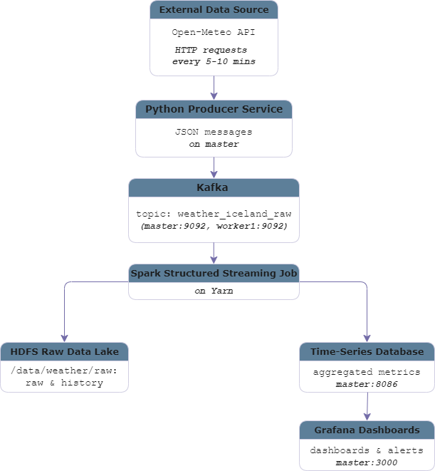

- Key query parameters:
Metric name | Description
latitude, longitude | geographic coordinates for the location
hourly | comma-separated list of requested hourly variables
forecast_days | number of days to forecast
past_hours | number of past hours included, useful for short historical context
timeformat=unixtime | unix timestamps, easier to handle in Spark
timezone=UTC | common time zone for all locations
wind_speed_10m | wind speed at 10 m height
wind_gusts_10m | wind gusts at 10 m height
temperature_2m | air temperature at 2 m height
precipitation | total precipitation
pressure_msl | mean sea-level pressure

Project Schema

Overview
The system will be implemented using the architecture required in the course:
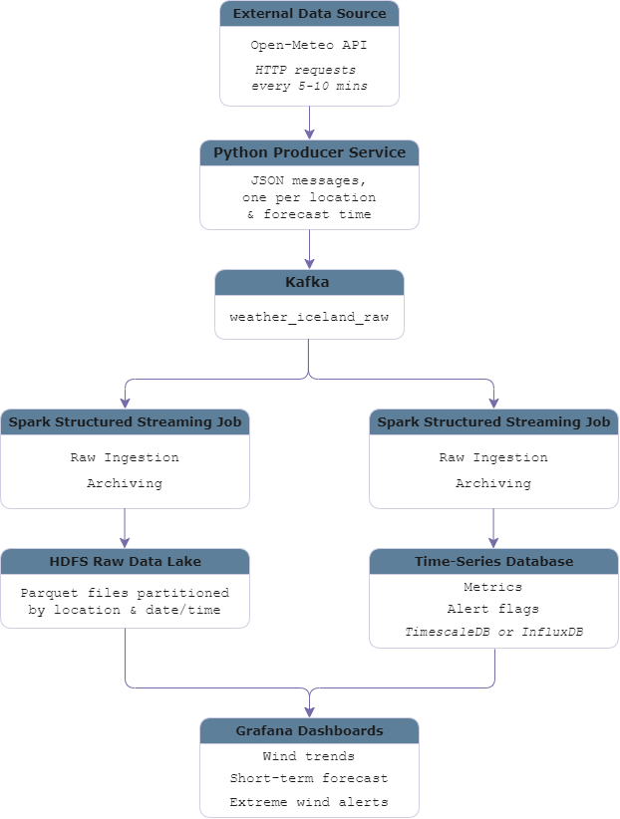

Short-Term Wind Monitoring Service
- Pipeline
For each monitored location, the system will:
- Continuously ingest hourly wind forecasts for the next 48 hours.
- Use Spark Structured Streaming to compute rolling statistics over sliding time windows:
- Average and maximum wind speed
- Maximum wind gusts
- Simple wind trend indicators
- Store these aggregated metrics in a time-series database for efficient querying and visualization.
- Provide near real-time Grafana dashboards showing wind evolution at different locations.
- Use cases
This service supports use cases like:
- Monitoring wind conditions around Reykjavík and Keflavík airport
- Comparing wind patterns between north (Akureyri) and south-west (Reykjavík/Keflavík) Iceland
- Quickly checking whether winds are strengthening or weakening over the next few hours

Service Extreme wind event detection and alerting
- Pipeline
For each monitored location, the system will:
- Reuse the same Open-Meteo forecast stream as the monitoring service, continuously ingesting hourly wind speed and gust forecasts for the next 48 hours into Kafka and then into Spark Structured Streaming
- Use Spark Structured Streaming to apply threshold checks over sliding time windows:
- Detect whether any hour in the window exceeds the extreme wind thresholds
- Count how many hours in the window are expected to experience extreme wind
- For each location and window, derive alert KPIs, such as:
- A binary flag indicating if extreme wind is expected in the upcoming window
- The expected duration of extreme wind within the window.
- Store these alert metrics in a dedicated table/measurement in the time-series database for efficient querying.
- Configure Grafana panels to:
- Highlight time ranges with extreme wind.
- Display summary views showing which locations are currently under warning and when the warnings start and end.
- Use cases
This service supports use cases like:
- Helping operators at Keflavík International Airport or coastal facilities quickly see upcoming periods with dangerous wind conditions
- Providing an overview of when and where extreme wind is expected, supporting decisions about road closures, bus schedules, and tour cancellations
- Identifying multi-hour or multi-location extreme wind episodes, allowing stakeholders to prepare in advance

Key Metrics and KPIs
This section defines the main metrics and Key Performance Indicators used in the project.

Wind and Weather Monitoring KPIs
These KPIs describe the predicted weather in the near future and are mainly displayed as time-series plots in Grafana.
Metric name | Description
wind_speed_10m_current | latest forecast wind speed at 10 m height for a given location
wind_gusts_10m_current | latest forecast wind gust at 10 m height
temperature_2m_current | latest forecast air temperature at 2 m height
precipitation_current | latest forecast hourly precipitation
pressure_msl_current | latest forecast mean sea-level pressure

Extreme Wind Alert KPIs
The second group of KPIs focuses on detecting and summarizing extreme wind situations based on predefined thresholds.
Metric name | Description
extreme_wind_flag_next_3h | binary flag indicating whether any extreme wind event is expected in the next 3 hours for a location
extreme_wind_flag_next_6h | binary flag indicating whether any extreme wind event is expected in the next 6 hours for a location
extreme_wind_duration_next_6h | number of forecast hours within the next 6 hours where wind speed or gusts exceed the threshold
extreme_wind_duration_next_12h | number of forecast hours within the next 12 hours with extreme wind conditions
extreme_wind_duration_next_12h | composite score combining maximum wind speed/gust and duration to measure how “severe” the event may be

System Health and Performance KPIs
In addition to weather-related metrics, the project also tracks KPIs that describe the health and performance of the data pipeline itself.
Metric name | Description
ingestion_rate_events_per_min | number of forecast records ingested from the API and written into Kafka per minute
kafka_consumer_lag | difference between the latest Kafka offset and the offset processed by Spark
spark_batch_processing_time | average processing time for a micro-batch in Spark Structured Streaming
end_to_end_latency | time between a record entering Kafka and the corresponding metrics being written to the DB
hdfs_raw_data_volume | total size of raw forecast data stored in HDFS over time

Github Link
https://github.com/tengzhezhang0-sketch/projet_esilv

